KISSsoft System Module 2025

User friendly
- KISSsoft look and feel
- Multi windows operations

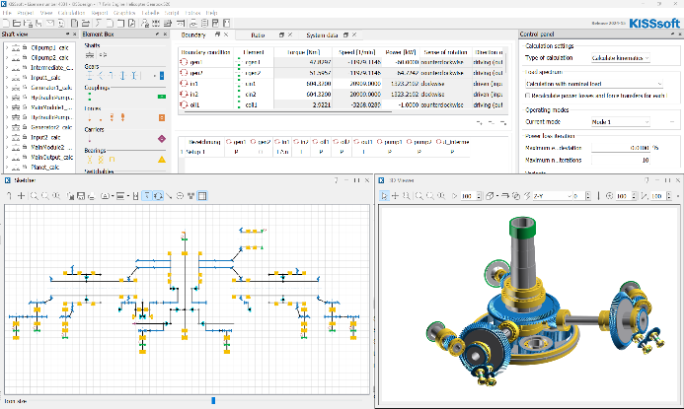

In KISSsoft® System Module windows and tabs may be arranged over several screens to accelerate the work flow and provide visibility of the system topology while optimizing individual components.

3D view
- Automatically created from part properties
- Allows for import of CAD data for collision check

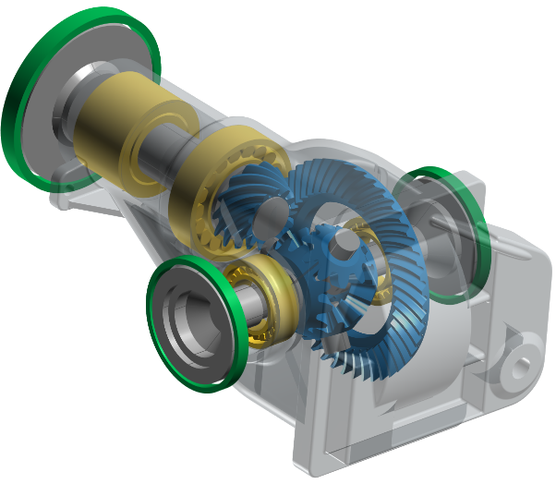
Whatever topology is defined in the sketcher or tree structure of the model and whatever gear and shaft details are designed, the 3D viewer allows for a fast check of the arrangement and use of design space.

Exciting frequences
- Gear mesh, hunting and assembly frequencies
- Bearing fundamental and passing frequencies

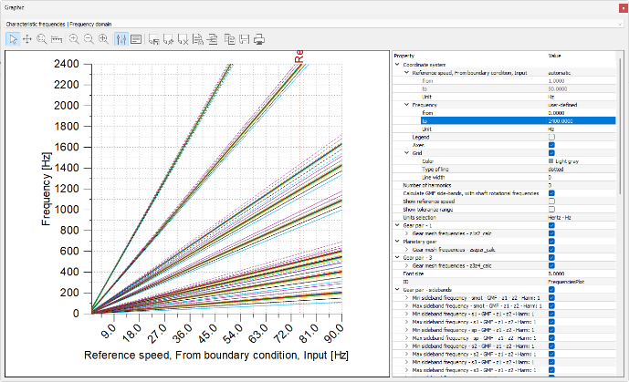

Knowing gear and bearing frequencies helps for fault detection to prevent failure or plan maintenance actions. Frequencies are calculated over a speed range, considering harmonics and sidebands.

Topology definition
- Definition as a schematic in the sketcher
- Use mouse and keyboard to model

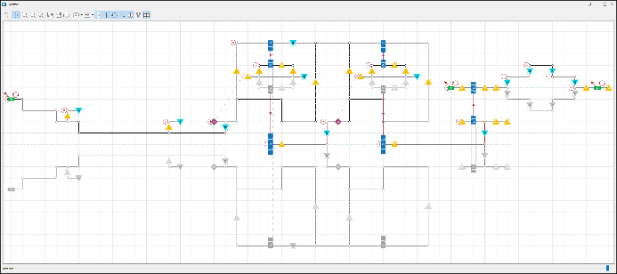

The sketcher allows for definition of the topology of a gearbox or transmission as if using pen and paper. Using mouse and keyboard, the system is drawn on a grid.

Annotations
- Visibility of key component properties
- Element labels showing element names

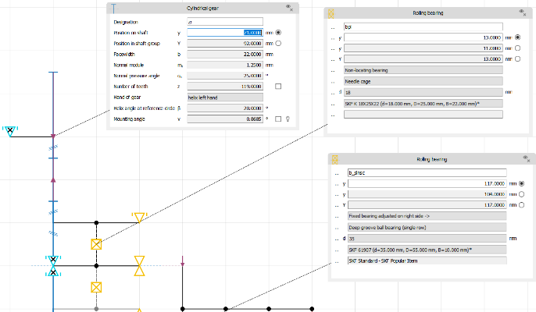

Annotations give a quick overview of key parts data like number of teeth and module or shaft total length or bearing designation This simplifies communication in design reviews or when explaining the design.

Tabular data summaries
- List of component properties
- On subsystem or system level

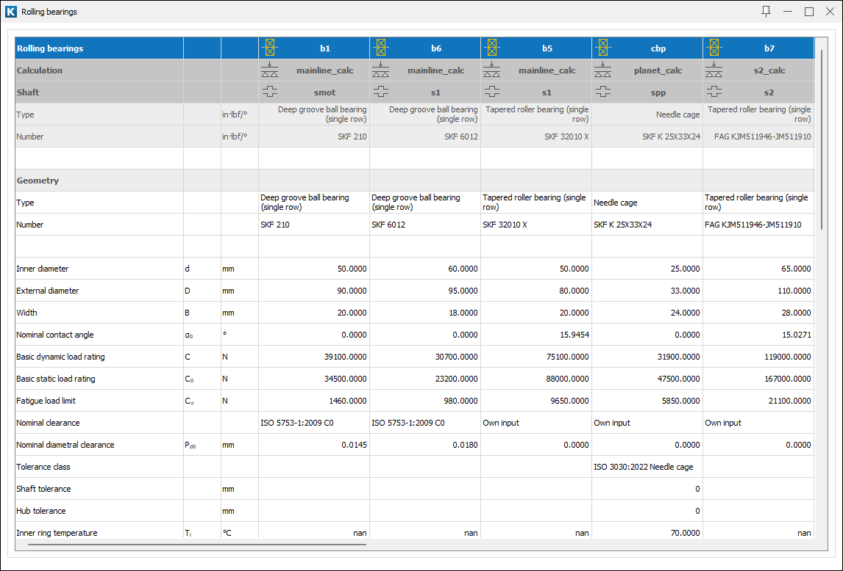

Key data per component type is summarized in tables. The tables inform also about the association of a part, e.g. for a bearing on which shaft it is located. In future, tables may be exported, and the content changed.

Forced response analysis
- Excitation from gear mesh and other
- Resulting bearing forces over time

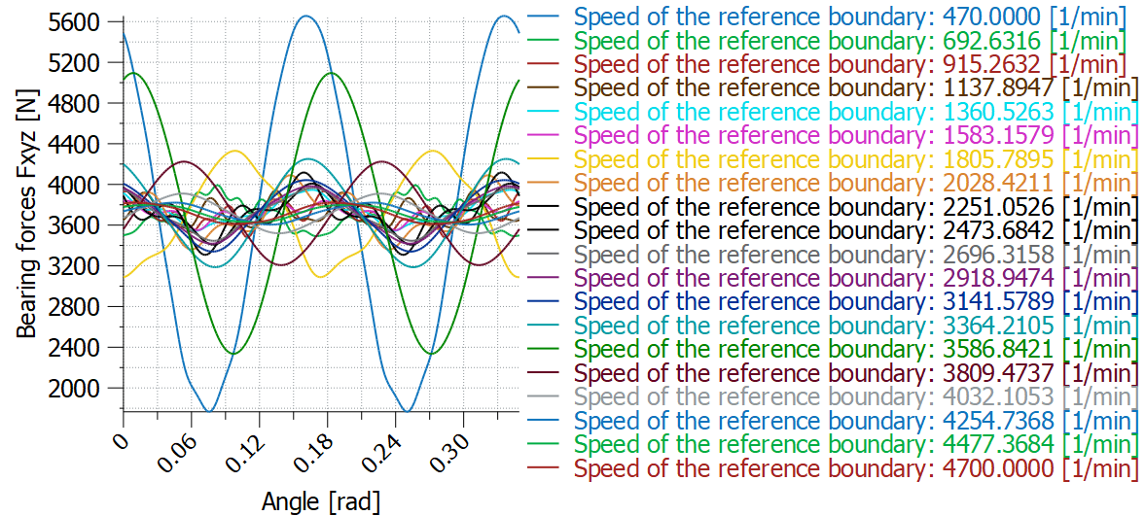

The forced response analysis considers excitation from the transmission error in all gear meshes, shaft imbalance and torque ripple. Time dependent bearing forces allow for calculation of housing noise.

System deformation
- 3D display of deformed components
- For assessment of gear mesh misalignment

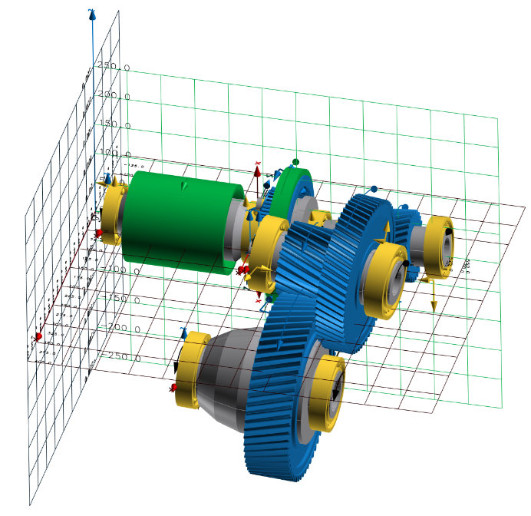

The system deformation is visualized. This helps to understand key contributions to gear misalignment, be it bearing, shaft, gear body or housing deflection.

A test version is available upon request from
our website at: www.kisssoft.com/trial

